PROJECT BASIC INFORMATION

|  |  |  |  |  |
| --- | --- | --- | --- | --- |
| Project Name | Selenium WebDriver Web Application Response Time Testing with Java | | | |
| Name of Product | Google Maps | | | |
| Product Description | A web mapping platform and consumer application offered by Google | | | |
| Project Description | <Mission of project>  Conduct testing to measure the response time of this web application  <Project’s output product>  Test Summary Report & Evaluation | | | |
| Project Type | Testing/Measurement | | | |
| Project Duration | Start date | 06/11/2022 | End date | 06/12/2022 |

Test Criteria

|  |  |
| --- | --- |
| Internet Connection Speeds | 3 different internet conditions |
| Inputs | 3 different destinations |

5 attempts each will be conducted.

Testing Tools

|  |  |  |
| --- | --- | --- |
| No. | Resources | Description |
| 1. | Selenium WebDriver | WebDriver drives a browser natively, as a user would, either locally or on a remote machine using the Selenium server, marks a leap forward in terms of browser automation. |
| 2. | Java | Java is a programming language and computing platform first released by Sun Microsystems in 1995. |
| 3. | Visual Studio Code | Visual Studio Code is a code editor redefined and optimized for building and debugging modern web and cloud applications. |
| 4. | Windows 10 | Windows 10 is a Microsoft operating system for personal computers, tablets, embedded devices and internet of things devices. |

Test Report

|  |  |  |
| --- | --- | --- |
| EXECUTED | PASSED | 44 |
| FAILED | 1 |
| PENDING | 0 | |
| IN PROGRESS | 0 | |
| BLOCKED | 0 | |
| Total | 45 | |

Test Data

Average Response Time Chart (Unit: milliseconds)

|  |  |  |  |  |
| --- | --- | --- | --- | --- |
|  | “CN Tower” | “Canada’s Wonderland” | “Kensington Market” | average |
| 34.2 Mbps download  22.5 Mbps upload  Latency: 26 ms | 9,519.2 | 8,618.4 | 7,939.6 | 8,692.4 |
| 8.30 Mbps download  9.01 Mbps upload  Latency: 15 ms | 10,517.5 | 9,451.6 | 8,852.8 | 9,607.3 |
| 8.96 Mbps download  2.71 Mbps upload  Latency: 28 ms | 14,014. | 12,711. | 11,754. | 12,826.3 |
| Average | 11,350.2 | 10,260.3 | 9,515.5 | 10,375.3 |

Success Rate Chart

|  |  |  |  |  |
| --- | --- | --- | --- | --- |
|  | “CN Tower” | “Canada’s Wonderland” | “Kensington Market” | average |
| 34.2 Mbps download  22.5 Mbps upload  Latency: 26 ms | 100% | 100% | 100% | 100% |
| 8.30 Mbps download  9.01 Mbps upload  Latency: 15 ms | 80% | 100% | 100% | 93.3% |
| 8.96 Mbps download  2.71 Mbps upload  Latency: 28 ms | 100% | 100% | 100% | 100% |
| Average | 93.3% | 100% | 100% | 97.8% |

Test Log

Outputs of the executed tests

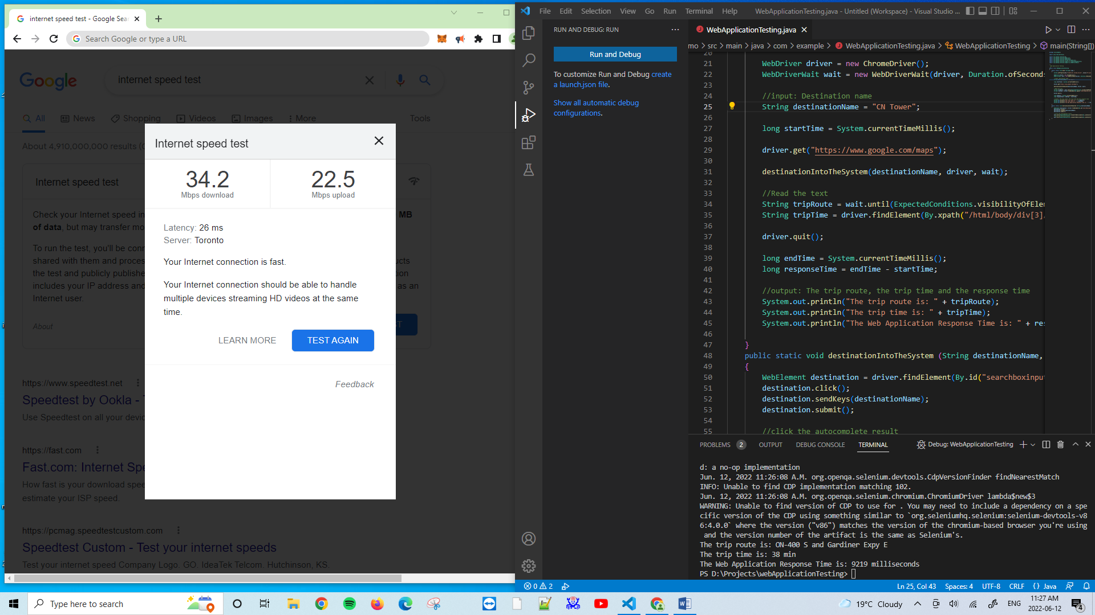

Figure 1. Download: 34.2 Mbps, Upload: 22.5 Mbps; Latency: 26 ms; “CN Tower”.

Test Conditions

Internet Connection Speed: 34.2 Mbps download, 22.5 Mbps upload; Latency: 26 ms.

Input: “CN Tower”.

Attempt #1:

The trip route is: ON-400 S and Gardiner Expy E

The trip time is: 38 min

The Web Application Response Time is: 10423 milliseconds

Attempt #2:

The trip route is: ON-400 S and Gardiner Expy E

The trip time is: 38 min

The Web Application Response Time is: 10309 milliseconds

Attempt #3:

The trip route is: ON-400 S and Gardiner Expy E

The trip time is: 38 min

The Web Application Response Time is: 9219 milliseconds

Attempt #4:

The trip route is: ON-400 S and Gardiner Expy E

The trip time is: 38 min

The Web Application Response Time is: 9056 milliseconds

Attempt #5:

The trip route is: ON-400 S and Gardiner Expy E

The trip time is: 39 min

The Web Application Response Time is: 8586 milliseconds

Test Conditions

Internet Connection Speed: 34.2 Mbps download, 22.5 Mbps upload; Latency: 26 ms.

Input: “Canada’s Wonderland”.

Attempt #1:

The trip route is: Jane St/York Regional Rd 55

The trip time is: 10 min

The Web Application Response Time is: 9245 milliseconds

Attempt #2:

The trip route is: Jane St/York Regional Rd 55

The trip time is: 10 min

The Web Application Response Time is: 8618 milliseconds

Attempt #3:

The trip route is: Jane St/York Regional Rd 55

The trip time is: 10 min

The Web Application Response Time is: 8131 milliseconds

Attempt #4:

The trip route is: Jane St/York Regional Rd 55

The trip time is: 10 min

The Web Application Response Time is: 8533 milliseconds

Attempt #5:

The trip route is: Jane St/York Regional Rd 55

The trip time is: 10 min

The Web Application Response Time is: 8565 milliseconds

Test Conditions

Internet Connection Speed: 34.2 Mbps download, 22.5 Mbps upload; Latency: 26 ms.

Input: “Kensington Market”.

Attempt #1:

The trip route is: ON-400 S

The trip time is: 48 min

The Web Application Response Time is: 7499 milliseconds

Attempt #2:

The trip route is: ON-400 S

The trip time is: 48 min

The Web Application Response Time is: 8535 milliseconds

Attempt #3:

The trip route is: ON-400 S

The trip time is: 48 min

The Web Application Response Time is: 8105 milliseconds

Attempt #4:

The trip route is: ON-400 S

The trip time is: 48 min

The Web Application Response Time is: 7662 milliseconds

Attempt #5:

The trip route is: ON-400 S

The trip time is: 48 min

The Web Application Response Time is: 7897 milliseconds

Test Conditions

Internet Connection Speed: 8.30 Mbps download 9.01 Mbps upload Latency: 15 ms.

Input: “CN Tower”.

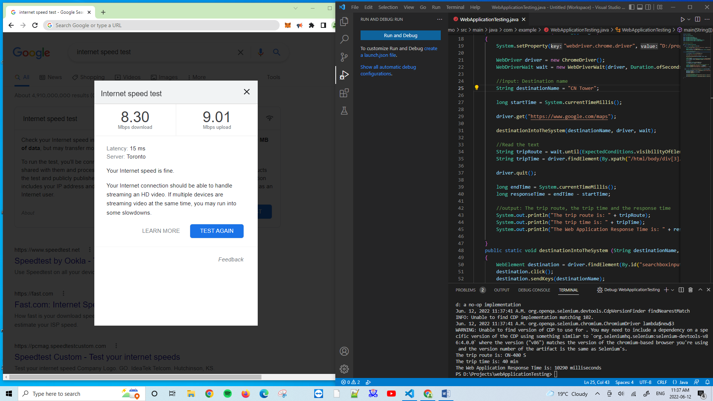

Figure 2. Download: 8.30 Mbps, Upload: 9.01 Mbps; Latency: 15ms; “CN Tower”.

Attempt #1:

The trip route is: ON-400 S

The trip time is: 40 min

The Web Application Response Time is: 10290 milliseconds

Attempt #2:

The trip route is: ON-400 S

The trip time is: 40 min

The Web Application Response Time is: 10017 milliseconds

Attempt #3:

The trip route is: Don Valley Pkwy S

The trip time is: 43 min

The Web Application Response Time is: 11027 milliseconds

Attempt #4:

FAILED. Details on Figure 3.below.

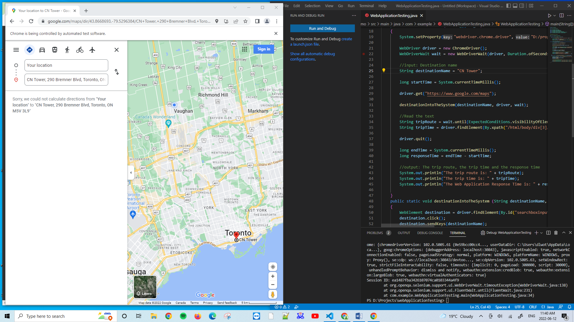

Figure 3. FAILED.

Attempt #5:

The trip route is: ON-400 S

The trip time is: 39 min

The Web Application Response Time is: 10736 milliseconds

Test Conditions

Internet Connection Speed: 8.30 Mbps download 9.01 Mbps upload Latency: 15 ms.

Input: “Canada’s Wonderland”.

Attempt #1:

The trip route is: Jane St/York Regional Rd 55

The trip time is: 10 min

The Web Application Response Time is: 9999 milliseconds

Attempt #2:

The trip route is: Jane St/York Regional Rd 55

The trip time is: 10 min

The Web Application Response Time is: 9337 milliseconds

Attempt #3:

The trip route is: Jane St/York Regional Rd 55

The trip time is: 10 min

The Web Application Response Time is: 9123 milliseconds

Attempt #4:

The trip route is: Jane St/York Regional Rd 55

The trip time is: 10 min

The Web Application Response Time is: 9590 milliseconds

Attempt #5:

The trip route is: Jane St/York Regional Rd 55

The trip time is: 10 min

The Web Application Response Time is: 9209 milliseconds

Test Conditions

Internet Connection Speed: 8.30 Mbps download 9.01 Mbps upload Latency: 15 ms.

Input: “Kensington Market”.

Attempt #1:

The trip route is: ON-400 S

The trip time is: 50 min

The Web Application Response Time is: 8442 milliseconds

Attempt #2:

The trip route is: ON-400 S

The trip time is: 51 min

The Web Application Response Time is: 8547 milliseconds

Attempt #3:

The trip route is: ON-400 S

The trip time is: 50 min

The Web Application Response Time is: 8727 milliseconds

Attempt #4:

The trip route is: ON-400 S

The trip time is: 50 min

The Web Application Response Time is: 9199 milliseconds

Attempt #5:

The trip route is: ON-400 S

The trip time is: 50 min

The Web Application Response Time is: 9349 milliseconds

Test Conditions

Internet Connection Speed: 8.96 Mbps download 2.71 Mbps upload Latency: 28 ms.

Input: “CN Tower”.

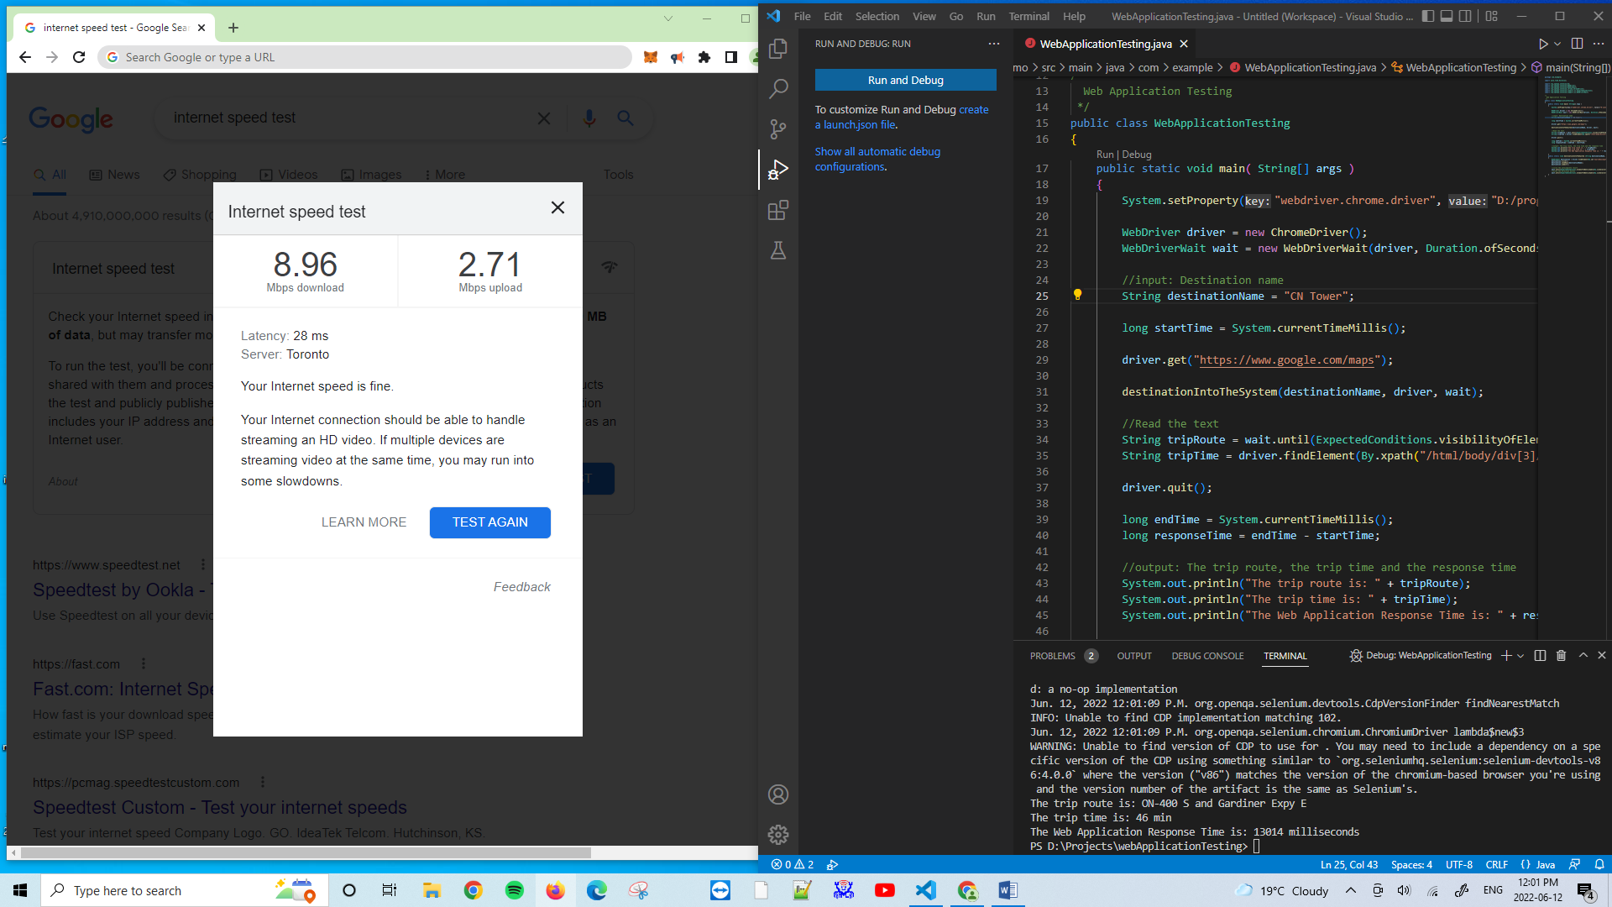

Figure 4. Download: 8.96 Mbps, Upload: 2.71 Mbps; Latency: 28ms; “CN Tower”.

Attempt #1:

The trip route is: ON-400 S and Gardiner Expy E

The trip time is: 46 min

The Web Application Response Time is: 13014 milliseconds

Attempt #2:

The trip route is: ON-400 S

The trip time is: 43 min

The Web Application Response Time is: 14561 milliseconds

Attempt #3:

The trip route is: ON-400 S

The trip time is: 43 min

The Web Application Response Time is: 14723 milliseconds

Attempt #4:

The trip route is: ON-400 S

The trip time is: 44 min

The Web Application Response Time is: 13763 milliseconds

Attempt #5:

The trip route is: ON-400 S

The trip time is: 43 min

The Web Application Response Time is: 14009 milliseconds

Test Conditions

Internet Connection Speed: 8.96 Mbps download 2.71 Mbps upload Latency: 28 ms.

Input: “Canada’s Wonderland”.

Attempt #1:

The trip route is: Jane St/York Regional Rd 55

The trip time is: 11 min

The Web Application Response Time is: 12486 milliseconds

Attempt #2:

The trip route is: Teston Rd/York Regional Rd 49 and ON-400 S

The trip time is: 9 min

The Web Application Response Time is: 14093 milliseconds

Attempt #3:

The trip route is: Jane St/York Regional Rd 55

The trip time is: 11 min

The Web Application Response Time is: 12827 milliseconds

Attempt #4:

The trip route is: Jane St/York Regional Rd 55

The trip time is: 11 min

The Web Application Response Time is: 11222 milliseconds

Attempt #5:

The trip route is: Jane St/York Regional Rd 55

The trip time is: 11 min

The Web Application Response Time is: 12927 milliseconds

Test Conditions

Internet Connection Speed: 8.96 Mbps download 2.71 Mbps upload Latency: 28 ms.

Input: “Kensington Market”.

Attempt #1:

The trip route is: ON-400 S

The trip time is: 51 min

The Web Application Response Time is: 11608 milliseconds

Attempt #2:

The trip route is: ON-400 S

The trip time is: 51 min

The Web Application Response Time is: 11514 milliseconds

Attempt #3:

The trip route is: ON-400 S

The trip time is: 51 min

The Web Application Response Time is: 12157 milliseconds

Attempt #4:

The trip route is: ON-400 S

The trip time is: 51 min

The Web Application Response Time is: 11968 milliseconds

Attempt #5:

The trip route is: ON-400 S

The trip time is: 51 min

The Web Application Response Time is: 11523 milliseconds

TEST SCRIPT

package com.example;

import java.time.Duration;

import org.openqa.selenium.By;

import org.openqa.selenium.WebDriver;

import org.openqa.selenium.WebElement;

import org.openqa.selenium.chrome.ChromeDriver;

import org.openqa.selenium.support.ui.ExpectedConditions;

import org.openqa.selenium.support.ui.WebDriverWait;

/*

  Web Application Testing

 */

public class WebApplicationTesting

{

    public static void main( String[] args )

    {

        System.setProperty("webdriver.chrome.driver", "D:/programming/chromedriver.exe");

        WebDriver driver = new ChromeDriver();

        WebDriverWait wait = new WebDriverWait(driver, Duration.ofSeconds(10,1));

        //input: Destination name

        String destinationName = "Kensington Market";

        long startTime = System.currentTimeMillis();

        driver.get("https://www.google.com/maps");

        destinationIntoTheSystem(destinationName, driver, wait);

        //Read the text

        String tripRoute = wait.until(ExpectedConditions.visibilityOfElementLocated(By.xpath("/html/body/div[3]/div[9]/div[9]/div/div/div[1]/div[2]/div/div[1]/div/div/div[4]/div[1]/div[1]/div[1]/div[2]/h1[1]/span"))).getText();

        String tripTime = driver.findElement(By.xpath("/html/body/div[3]/div[9]/div[9]/div/div/div[1]/div[2]/div/div[1]/div/div/div[4]/div[1]/div[1]/div[1]/div[1]/div[1]/span[1]")).getText();

        driver.quit();

        long endTime = System.currentTimeMillis();

        long responseTime = endTime - startTime;

        //output: The trip route, the trip time and the response time

        System.out.println("The trip route is: " + tripRoute);

        System.out.println("The trip time is: " + tripTime);

        System.out.println("The Web Application Response Time is: " + responseTime + " milliseconds");

    }

    public static void destinationIntoTheSystem (String destinationName, WebDriver driver, WebDriverWait wait)

    {

        WebElement destination = driver.findElement(By.id("searchboxinput"));

        destination.click();

        destination.sendKeys(destinationName);

        destination.submit();

        //click the autocomplete result

        wait.until(ExpectedConditions.elementToBeClickable(By.cssSelector("div[role='row']"))).click();

        //Click the Direction button

        wait.until(ExpectedConditions.elementToBeClickable(By.cssSelector("button[data-value='Directions']"))).click();

    }

}